Contents

***Proposal on Performance Testing***

***For***

TBS

|  |  |
| --- | --- |
|  |  |
| **Submitted By:** | Ranjan Kumar Singh |
| **Version** | 1.0 |
| **Date** | 3rd July’ 2015 |

1. Executive Summary 5

1.1. Roadmap Post Performance Testing Analysis 9

1.2. ’s Solution Offerings 10

1.3. Project Schedule 10

1.4. References 10

2. ’s Understanding of Requirements 11

3. Proposed Solution 13

3.1. In Scope 13

3.2. Out Scope Activities 14

3.3. Assumptions & Constraints 15

3.4. Testing Environment 15

3.5. Deliverables 15

4. Performance Testing Methodology 17

5. Annexure 2: Performance Scenarios & Reports 28

* 1. Roadmap Post Performance Testing Analysis
* Application Re-Engineering & Modernization
* Application Benchmarking
* Improved Hardware /Infrastructure recommendation based on results
* Application Enhancement to meet large volume user traffic
* Providing automated development suggestions for identified development needs
  1. ’s Solution Offerings

This document is intended to propose, in detail, the terms of engagement for performance testing of the www.timesjobs.com website. This document is dedicated to define the scope of work to be carried out under the said project.

* 1. Project Schedule

Proposes the completion of the pilot project in approximately 5 work weeks from the commencement.

The preceding are initial maintenance schedules for the envisaged portal. This schedule might undergo revision after the Analysis phase.

* 1. References

# Understanding of Requirements

Based on our understanding of requirements, we intends to perform load testing on the staging candidate website (www.timesjobs.com) to analyse the website load statistics. The test will need to allow for 100 different accounts being used in a day. The number of transaction covered should include:

* Home Page.
* SEO landing Pages
* Search
* Search Result Page.
* Job detail Page
* Job Apply flow (internal)
* Job Apply flow (external).
* Login and Logout.

The below picture depicts the scope of type of testing required to be done as a part of this pilot. There are various tests that’s need to be performed end-to end for web testing.

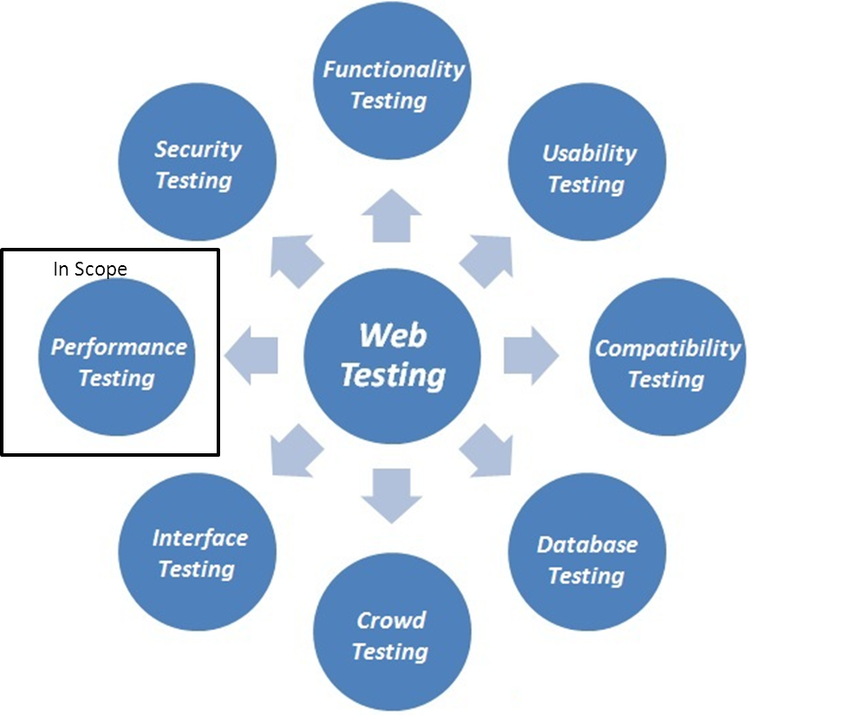

Based on requirement, will perform performance testing in scope of this pilot project. The objective of the Performance testing is to check the web application is working under the heavy load. Performance testing is categorized into two parts:

* Web Stress Testing
* Web Load Testing.

This would include-

* Check if response times of Website application under different speeds of connections.
* Check if site handles many simultaneous user requests at same time.
* Check if how your web application sustain under the peak loads
* Check if large input data from users.
* **Check the behaviour of web application if simultaneous connection to Database**.
* **Check if how the web site pulls through if crash occurs due to peak load**.

# Proposed Solution

* 1. In Scope
* Load testing with a scenario to allow for 100 different user accounts being used in a day. The transactions performed will be as below:
  + Home Page.
  + SEO landing Pages
  + Search
  + Search Result Page.
  + Job detail Page
  + Job Apply flow (internal)
  + Job Apply flow (external).
  + Login and Logout.
* Analysis of website for different scenario- Check for different path from where we can put load on the website
* Jmeter tool /methodology for load / performance testing
* Preparation of test script for different scenario- Creation of script for different scenario - Account creation. We will also cover all possible scenario which are important as per business prospective
  + Home Page.
  + SEO landing Pages
  + Search
  + Search Result Page.
  + Job detail Page
  + Job Apply flow (internal)
  + Job Apply flow (external).
  + Login and Logout.
* Preparation of different type of reports- will provide different type of reports on different load to view the result like -
  + - Summary Report -
    - View Result in Table Report
    - Response Time Graph
    - Aggregate Graph

Overall analysis of the **Candidate** **website** will cover on the basis of Response Time for a particular page from the server. In reports you can see the following result with following attributes:

**Label - Name of the page. This allows identical labels from different thread groups to be collated separately if required.**

**Samples - The number of users with the same label**

**Average - The average response time of a set of results**

**Min - The lowest response time for the samples with the same label**

**Max - The longest response time for the samples with the same label**

**Std. Dev. - The standard deviation of the sample response time**

**Error % - Percent of requests with errors**

**Throughput - The Throughput is measured in requests per second/minute/hour. The time unit is chosen so that the displayed rate is at least 1.0. When the throughput**

**is saved to a CSV file, it is expressed in requests/second, i.e. 30.0 requests/minute is saved as 0.5.**

**Kb/sec - The throughput measured in Kilobytes per second**

**Avg. Bytes - Average size of the sample response in bytes.**

* Preparation of overall performance test report document - Overall performance test report on the basis of different types of load on different time duration
  1. Out Scope Activities
* Functional Testing: (Functionality testing of software is testing conducted on a complete, integrated system to evaluate the system's compliance with its specified requirements)
* Security testing: (The security testing is carried out to ensure that is any information leakage in terms of encrypting the data)
* Database testing (Checking the integrity of UI data with Database Data, why junk data is displaying in UI other than that stored in Database)
* Usability testing Usability (Usability testing is a technique used in user-centered interaction design to evaluate a product by testing it on user)

**Assumptions & Constraints**

* TJTECH will provide the functional document covering the detail functionality of the website wherever user is **HIGH** on site.
* What is our anticipated average number of users (normal load). As per discussion (180-250 user per server)
* What is our anticipated peak number of users.(**300** users)
* TJTECH will provide access to UAT/Staging environment required to perform load testing it should be of the same configuration as of live environment. ( **As per discussion we will use 102 server**.)
* TJTECH representative will review the test scripts and subsequent sign off.
* Test Data for accounts has to be prepared and same has been parameterize within the framework.
* **NEW RELIC** needs to be configured on **102** server to monitor the server performances.

3.3.1 BECHMARKING DATA

DATA- **180 to 200** concurrent user per server, standard response times should be given .

* 1. Testing Environment

Team will be performing performance testing on test environment provided by TJTECH and various details as listed in section 3.3 would be required from TJTECH.

**Tools & Technology**

|  |  |
| --- | --- |
| **Testing Tools** | **Description** |
| JMeter 2.11 | Used to test performance both on static and dynamic website |

* 1. Deliverables

will provide different type of test reports:

* + - Summary Report
    - View Result in Table Report
    - Response Time Graph
    - Aggregate Graph

(For Sample reports of similar test scenarios attached below -)

# Performance Testing Methodology

The performance testing methodology consists of six phases. Each phase is completed with a

Deliverable or Deliverables.

|  |  |
| --- | --- |
| **Phase** | **Deliverable** |
| 1 - Project assessment | Assessment report |
| 2 – Planning | Test plan |
| 3 – Scripting | Test scripts |
| 4 - Test execution | Test scenarios, test results |
| 5 - Results analysis | Results summary |
| 6 - Reporting | Performance test report |

**Phase 1 – Project assessment**

The assessment is a process of gathering information. Requirements are analyzed by and the system and architecture studied to determine whether the requirements can be met with what is available in the specific environment. People should also be informed about your own requirements to perform the testing, including the time required to get useful results.

**Requirements**

The requirements for performance testing are usually very specific. When requirements are not known at the start of the assessment, finding out what they are should be part of the assessment process. Gather as much information as possible on every detail. This is crucial to the success of project. All the information will be used to produce good deliverables. Where something is not possible, communicate this properly to help manage expectations. In below table we look at some of the key areas the assessment covers.

|  |  |
| --- | --- |
| **Project Assessment** | |
| What must be achieved? (Business problem to  solve) | * Number of users * Acceptable response times * Business processes to test * Baselines * Data volumes |
| Architecture / Platform / Environment | * Understanding System Architecture * System components (Hardware &   Software) |
| Selection of tool | * Select the appropriate tool which is compatible with Architecture / Platform / Environment |
| Installation | * Software installation |
| Monitoring | * Requirement: must be monitored – can be monitored - Requirements put in place |
| Requirements to perform testing | * Access to key people * Hardware requirements * Software requirements * Data requirements |
| Other expectations | * Note down other expectation and point out limitations on your side |

**Phase 2 - Planning**

The information gathered during the project assessment is used for planning the performance testing and to start the test plan. The performance test plan must contain all the detail and acts as a check list and reference for test execution. The test plan forms the backbone of the testing process and is working document that is updated as the project progresses. Following are the component of performance testing test plan

Goal / Objectives / Scope / System diagram / Exclusions / Monitoring / Responsible people / Environment / Test hardware requirements / Test software requirements / Test data requirements / Test tool requirements / Security access / Test scenarios / Test execution / Results analysis /Report and feedback

**Phase 3 – Scripting**

Scripting is where the testing starts. As you learn the system and processes to script, make notes of response times and slow or very busy processes. All of these may be potential bottlenecks in the system. When we start executing scripts, monitor the processes you identified closely and you may identify the first problem before any formal performance or load test was done. Following are best practices during scripting

Confirm application is scriptable / Familiarise 100% with application / Make sure that scripts exercise the whole environment / Add response time measurements for every step / Take note of response times from the first script replay onwards Verify script execution in the database /Manage test data properly/ Run individual scripts at least once after every change or implementation

**Phase 4 – Test execution**

We refer to performance testing as a whole and this includes the testing as described in Below Table

|  |  |
| --- | --- |
| **Performance Testing** | |
| Type of Test | Description |
| Baseline test | Baseline the performance testing |
| Load test | Emulate production load on the system |
| Stress test | Load the system to breakpoint |
| Volume test | High data volumes / throughput. |

**Phase 5 – Results Analysis**

Performance testing is an iterative process with many test runs. A short results summary is the most effective way to communicate results between test runs and most often the time between test runs is not enough to compile a full test report. The summary documents are good physical deliverables that make your effort more visible to the people making the investment. The results summary includes the following:

Overview of test / Scenario summary / Number of users / Maximum users / Duration / Total throughput (Bytes) / Total hits / Average hits per second / Graphs / Response time graphs/ System resource graphs / Comparison graphs/ Recommendations for next test

**Phase 6 – Reporting**

The last phase is to report back on the findings and progress of the whole project. A full performance test report is delivered with a presentation to communicate the content of the report to the relevant people. The aim is to explain the content of the final report and answer questions anyone might have about the testing and findings. Detailed results are not included but a reference to the relevant results summaries are given where specific issues are discussed.



# Example of Performance Scenarios & Reports

1. Load time for home page <http://www.timesjobs.com/>

2. Check when user wants to perform registration action step1 **.**

(i) Go to [http://www.timesjobs.com](http://www.ozbet.com.au)

(ii)Click on Register Link.

(iii) enter all the valid data

(iv)Click on Register buton.

3. Check when user wants to perform **search** action from Home page.

(i).Go to [http://www.timesjobs.com](http://www.ozbet.com.au/)

(ii)Click on Search section from the top.

(iii)Fill following information from Keyword (a)Java (b)Testing (c)noida

(iv)Click on search button

4. Check when user wants to go **My Home** page**.**

 (i) Goto [http://www.timesjobs.com/](http://www.ozbet.com.au/)

 (ii) login to the site with valid id and password.

5. Check when user wants to go on **Login** page**.**

 (i) Goto [http://www.timesjobs.com/](http://www.ozbet.com.au/)

 (ii) Click on SignIn link and enter valid details.

6. Check when user wants to go on  **search result page and Job detail page .**

 (i) Goto [http://www.timesjobs.com/](http://www.ozbet.com.au/)

 (ii)Fill following information from Keyword (a)Java (b)Testing (c)noida

(iii)Click on search button.

(iv) click on any search result link to go to JD page.

7. Check when user wants to **Apply a Job (internal and external)** page.

 (i) Goto [http://www.timesjobs.com/](http://www.ozbet.com.au/)

 (ii) Apply A job.

(iii) verify successful message.

8. Check when user wants to **Browse a page where user is high for e.g SEO url’s**.

(i) Go to [http://www.timesjobs.com/](http://www.ozbet.com.au/)

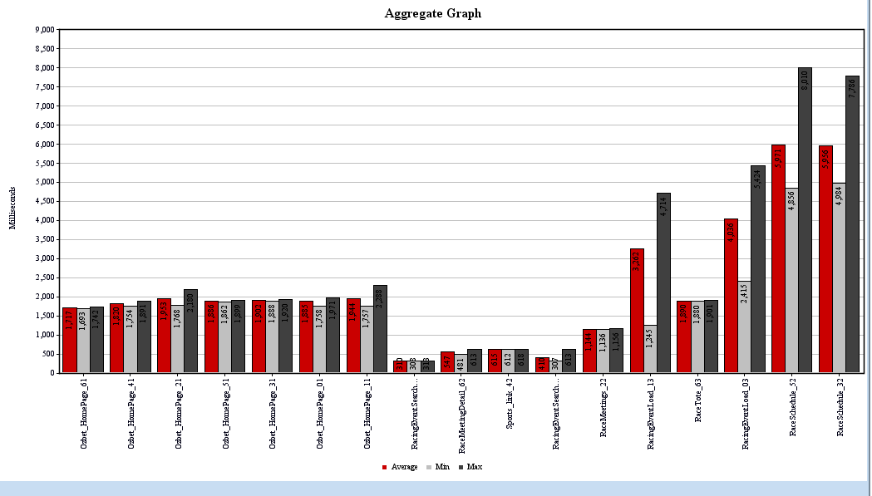

Aggregate Graph

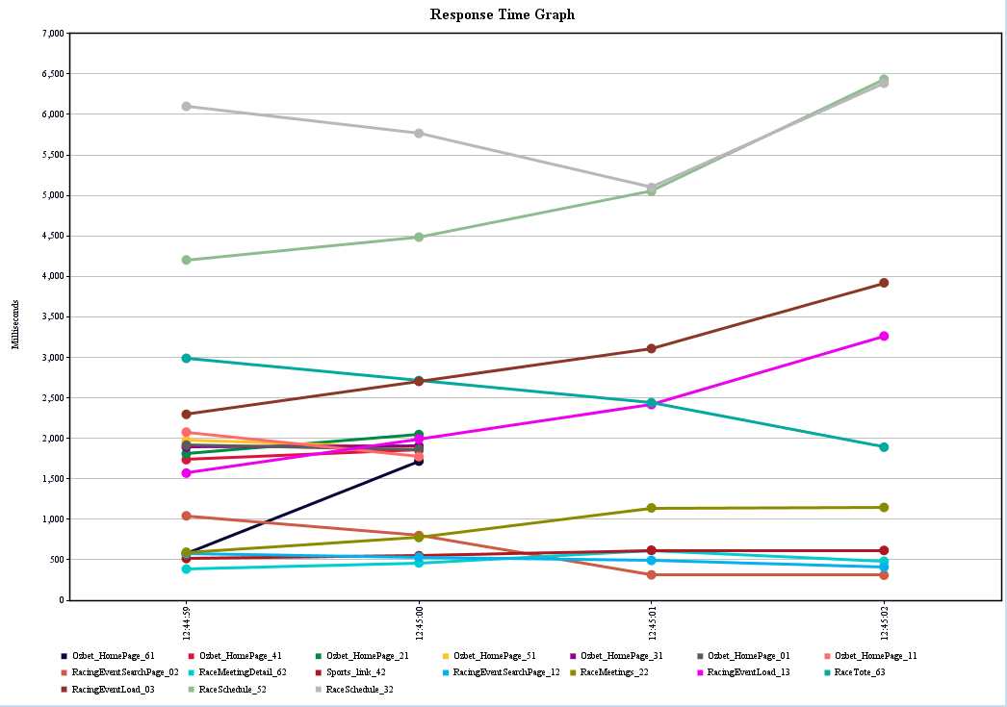

Response Time Graph

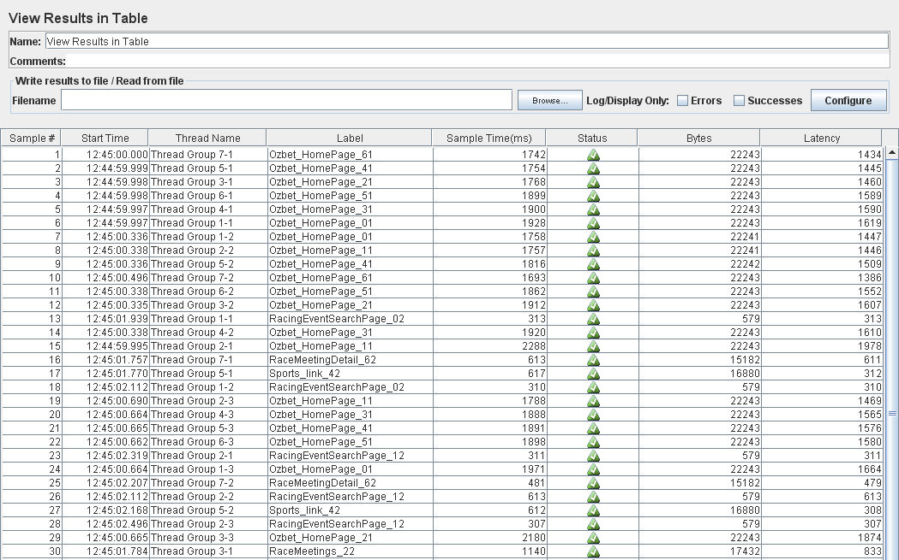

Result in Table1

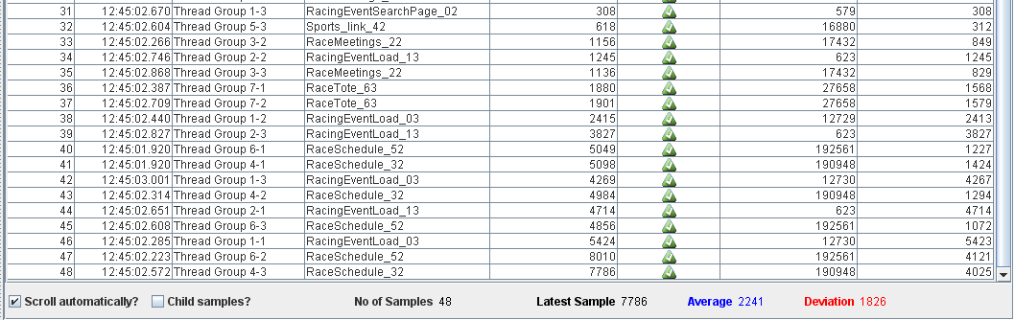

Result in Table2

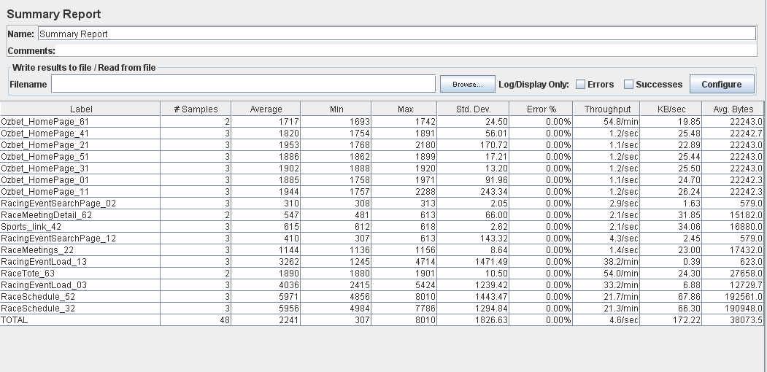

Summary Report

**Server Monitoring we will be using “New Relic”**